****Project objective:****

As a developer, write a program to search a string entered by a user from the array of strings.

****Background of the problem statement:****

You have an array of email IDs of employees. As a programmer, write a program to search the email ID entered by a user.

**Source Code :-**

**import** java.util.ArrayList;

**import** java.util.List;

**import** java.util.Scanner;

**import** java.util.regex.Matcher;

**import** java.util.regex.Pattern;

**public** **class** ValidationOfEmail {

**public** **static** **boolean** isValidEmail(String email) {

String regex = "^(.+)@(.+)$";

Pattern pattern = Pattern.*compile*(regex);

Matcher matcher = pattern.matcher(email);

**return** matcher.matches();

}

**public** **static** **void** main(String[] args) {

List<String> emails = **new** ArrayList<String>();

emails.add("aniket@email.com");

emails.add("aniketdhumal@email.com");

emails.add("ketan@email.com");

emails.add("aniket.dhumal.com");

emails.add("ketan.email.com");

**for** (String value : emails) {

System.***out***.println("The Email address " + value + " is " + (*isValidEmail*(value) ? "valid" : "invalid"));

}

System.***out***.println("Enter any email address to check");

Scanner sc = **new** Scanner(System.***in***);

String input = sc.nextLine();

System.***out***.println("The Email address " + input + " is " + (*isValidEmail*(input) ? "valid" : "invalid"));

}

}

**Output :-**

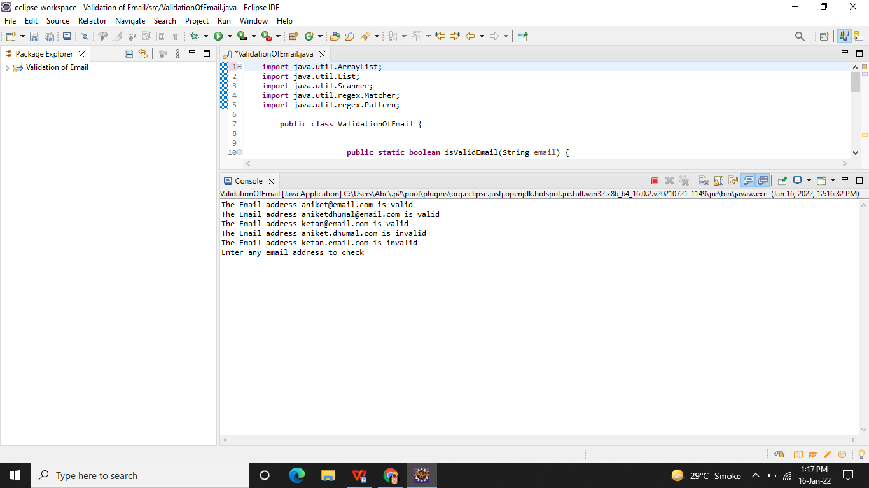

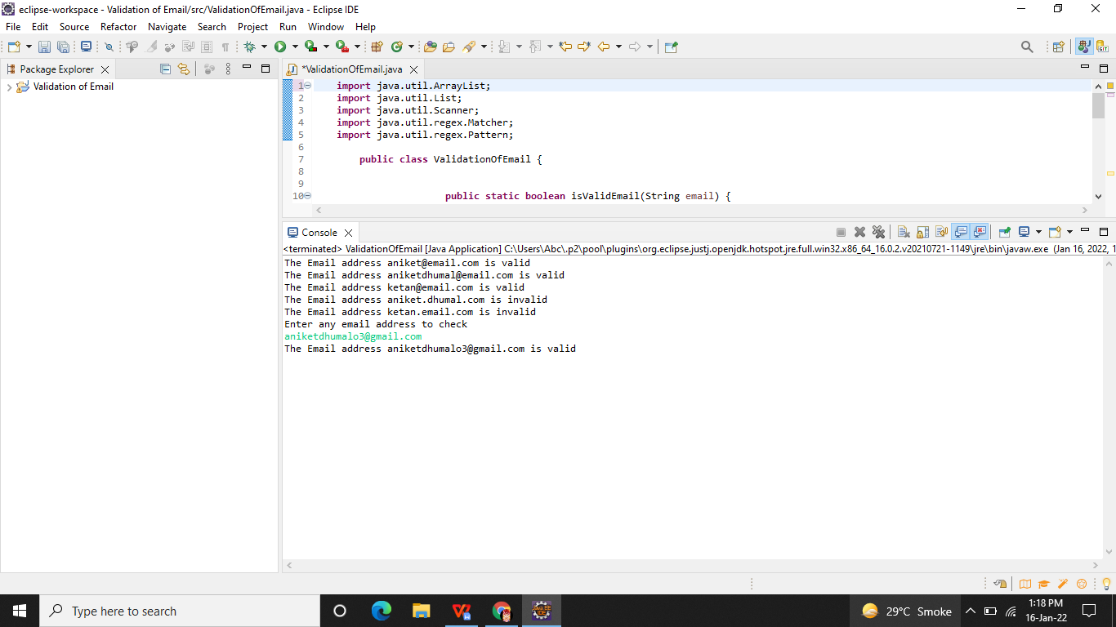

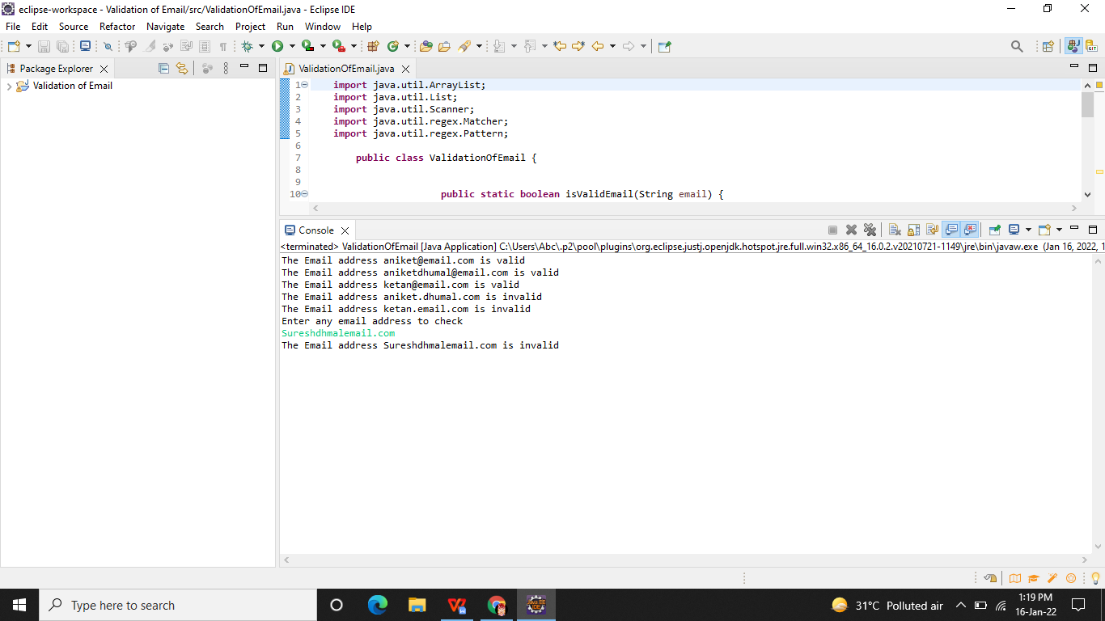

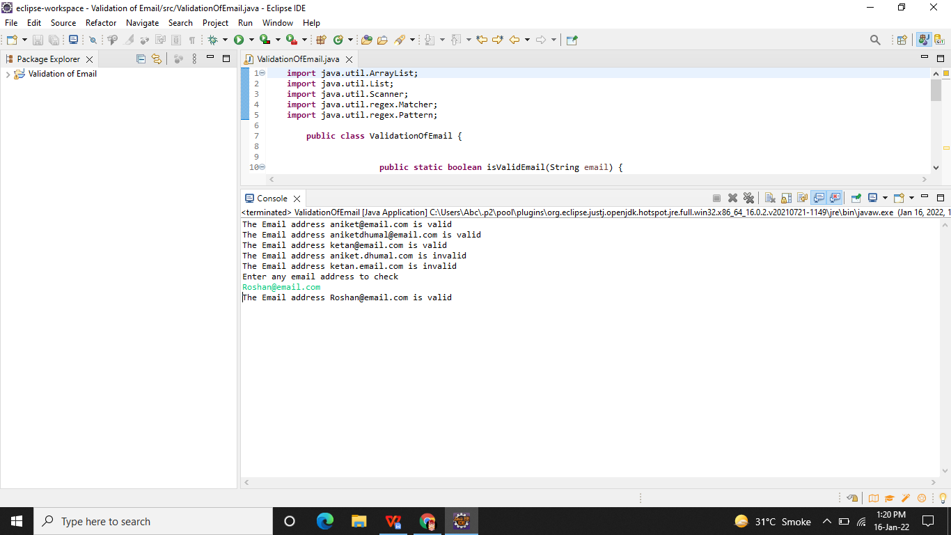

**Github Link -**

**https://github.com/Aniket03-op/Project.git**